Eclipse Import Repair
Analyzing and repairing issues that prevent diagnostic images from being used in Eclipse.

Analyzing the images using MicroDicom
- Open File Explorer In the folder above that containing the DICOM images for analysis.
- Right-Click on the folder containing the DICOM images and select “Open with MicroDicom DICOM Viewer”
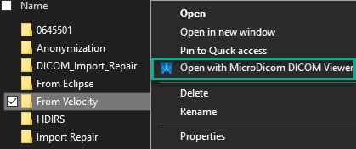
- The left panel contains the patient information and tree of images. Select the appropriate image set and then any image from within that set.
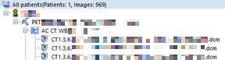
- The right-hand panel displays the DICOM header information as a list of “Tags”
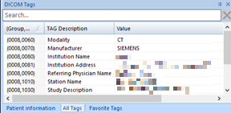
- If the DICOM tags are not showing click: View → DICOM Tags Pane.
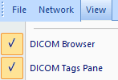
- Import errors can be diagnosed through the contents of the DICOM tags. Use the “PET Import Problems” tables to see what DICOM Tag information is associated with different issues.

PET Import Problems

Incorrect Image modality
Symptoms | - The images can be imported by Eternal Beam, but Contouring crashes when the image set is opened.
Diagnosis | - The DICOM Modality tag (0008, 0060) of the PET image series is labeled “CT”.  - In the past there have also been cases where the CT image sets have been incorrectly labeled as ‘NM’ or ‘OT’.  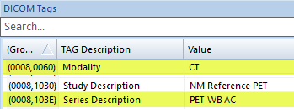
Epidemiology | - Recently, the most common case has been where the PET images have been given the Modality ‘CT’.  - This occurs infrequently, but in short bursts.  - The problem is usually resolved on the sending end within a day.  - When one is found watch for other image sets send from the same institution within a 1-2 day time window.
Treatment | - Image series that have been imported with the incorrect modality must be deleted from Eclipse. This is done in the “Selection” workspace.  - Replace the DICOM Modality (0008, 0060) value with the correct one (‘PT’ or ‘CT’.

Invalid Characters
Symptoms | - The images cannot be imported.  - Import error message states: Value is invalid: String contains ’\’ ….  - Alternate Import error message: “The patient of the data to be imported is unidentified or none of the data could be imported”.
Diagnosis | - The DICOM “Body Part Examined” tag (0018, 0015) in the image series begins with a “/”.  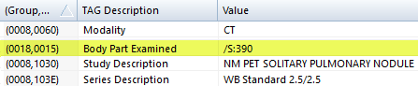  - In the past there have also been cases where the DICOM “Other Patient IDs” tag (0010, 1000) – No longer in use -- began with a “/”.  - Technically any String DICOM value beginning with a “/”could be the case of this.  - Note: the “/” is actually not present in the header, this is just MicroDicom’s way of saying the value give can’t be converted into printable characters.
Epidemiology | - Recently, this problem has resulted from “illegal” characters in the CT BodyPart DICOM header tag.  - In the past there have also been cases where the DICOM “Other Patient IDs” tag (0010, 1000) contained the “illegal” characters, but this tag is no longer in use, so it is unlikely to be found here.  - These are relatively common.  - Almost all of these cases have been in image sets coming from Ottawa, but not all images coming from Ottawa have this problem.
Treatment | - Clear the offending value in the DICOM tag.

Mismatched addresses
Symptoms | - Eclipse crashes while attempting to import the images.  - Import error message includes the text: “Cannot insert duplicate key row in object 'dbo.Equipment' ”.
Diagnosis | - The DICOM “InstitutionAddress” tag (0008, 0081) is different for the CT and PET images, while other “Device References” remain the same:  Manufacturer (0008,0070),  Institution Name (0008,0080),  Station Name (0008,1010),  Institutional Department Name (0008,1040),  Manufacturer Model Name (0008,1090),  Device Serial Number (0018,1000),  Software Versions (0018,1020)  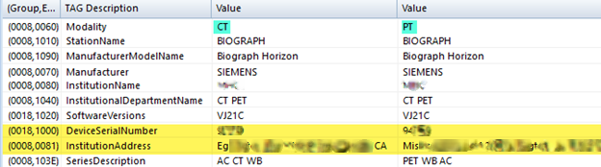
Epidemiology | - This error is unique to PET image sets coming from Mississauga and occurs with all PET image sets coming from there.  - This is so common that when diagnosing an import issue, I first check whether it came from Mississauga, and if it did, proceed assuming that this is the problem.  - This problem arises from a known issue, in the way Varian uniquely identifies diagnostic equipment in its database. Info from Varan below:  - DICOM Import/Export application checks the uniqueness of all equipment values whereas the dbo.Equipment table’s index XAK1Equipment checks all equipment values except the InstitutionAddress  - Therefore, if only the InstitutionAddress is different during the insertion of a new entry in the dbo.Equipment table, the operation fails and throws an error as it is considered as a duplicate entry
Treatment | - Clear the InstitutionAddress value in the DICOM tag.

